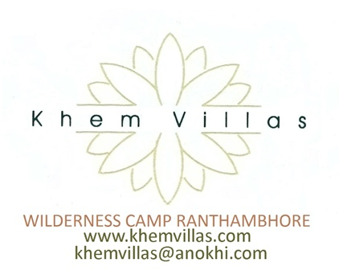

HEALTH AND SAFETY (Version 1)
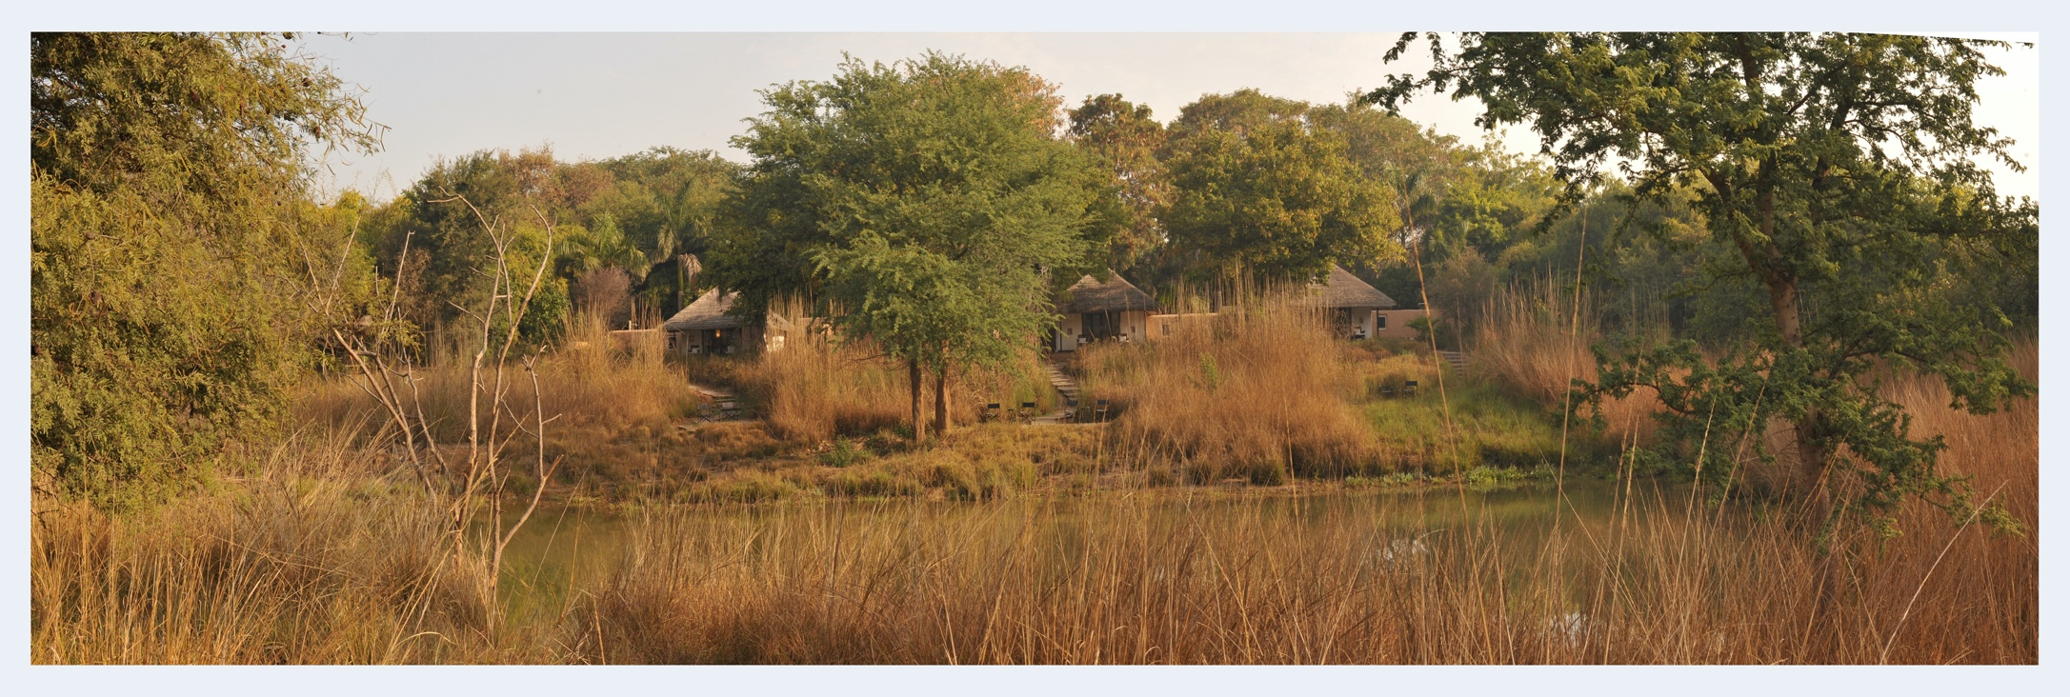

INTRODUCTION
( This is not a final document if better protocols come to light these will be added)

Khem Villas is a boutique luxury jungle camp located on the edge of Ranthambhore. While the current Covid 19 crisis has hit the travel industry Khem Villas provides a unique and safe travel experience for the following reasons:

- Khem Villas has been established and owned by a prominent Medical Doctor who has been working in the health care field in the District for over 30 years having established the largest most modern Hospital of the District. His experience will bring a lot of medical protocols of disease prevention to the camp which we will implement in earnest to make sure that our staff and guests are all safe from catching the infection while at Khem Villas
- Khem Villas is an outdoor camp located in 25 acres of privately owned forest encouraging guests to spend minimum time in the rooms / tents. As we all know being outdoors is the safest place to be in this time.
- The restaurant is open air dinning there is no airconditioned indoor dinning once again reinforcing the outdoor climate which is best for the current time
- All cottages and tents are stand alone units with no connecting corridors and doors providing very little chance of cross contamination while staying here. There are no TVs in the rooms so guests are encouraged outdoor activity with each tent / cottage offering private verandas to enjoy the scenery. The cottages all have a 8 foot wide French door opening directly outside with large windows on both sides allowing rooms to be well aerated while guest are staying and during turn around further helping keep the rooms fresh and sanitised. Similarly the tents being fabric have air passing through all the time and have 6 windows offering cross ventilation. The sunlight directly on the tents provide ideal natural conditions of sanitisation through heat, air and sunlight. None of the rooms have carpets again making deep cleaning easy and effective.
- We will not be opening the full hotel our 4 standard rooms will be kept for quarantine and 2 tents and 2 cottages will not be sold to allow atleast 24 hours before next guest check in to give further time for deactivation of the virus through natural process after deep cleaning.

OTHER PROACTIVE MEASURES WE WILL BE TAKING

- No third party drivers will be permitted beyond the parking area.
- Khem Villas does not offer any residential accommodation to third party drivers
- Only in house guests can dine and use any of the Khem Villas facilities like the bar etc.
- We will recommend safari excursions with drivers and guides that we know follow safety sanitisation protocols.
- All safari vehicles will be sanitised before and after safari and drivers and guides will have to wear masks, use hand sanitizers and their temperature will be recorded before every safari.
- We are trying to establish Covid testing at our hospital which should be in place by the time we restart hopefully in October. Once this happens all the staff will be tested for infection and antibody testing to know who are negative and who have developed antibodies

STAFF TRAINING / PROTOCOLS

Doctors from our hospital will provide staff training in the following:

- Recognising symptoms: Fever, Fatigue, Dry Cough, Shortness of breath, loss in taste, Sore throat, Diarrhoea.
- They will be educated in how the disease is transmitted and what measures to take to stop transmission ie wash hands, cover their face, avoid touching mouth eye nose, maintain 6 feet distance and isolate / test if ill
- Separate staff entrance will be used for staff coming to and going off duty. Every staff will be screened and their temperature recorded before being allowed in. Every staff will have to shower using soap before putting on the uniform. Automatic / foot operated soap and sanitizer dispensers will be put in common staff areas for regular hand washing. All staff will be provided masks and gloves and service staff where required will be provided face screens to minimise disease transmission. PPE kits will be provided if any suspected guest is found to deep clean the room
- Staff lockers will be decontaminated and deep cleaned every day, uniforms will cleaned under 80 degrees celcius in commercial in house laundry everyday. Washable laundry bags or disposable laundry bags will be provided for staff to put their laundry in for cleaning.
- Staff will be told to stay home if they have any symptoms relating to Covid 19 and will not be allowed to resume duty until they test negative in 2 tests 14 days apart.

GUEST ARRIVAL AND RECEPTION PROTOCOLS

- Only guests with a confirmed reservation will be allowed to check in
- If there is a requirement by government that they have a relevant health certification from immigration etc this will be checked before check in
- All arriving guests will be checked for temperature and a questionnaire will be filled related to Covid 19 symptoms
- Separate accommodation for providing quarantine facility will be available at all times should any guest be found positive and this will be in an area cut off from the rest of the accommodations with separate entry and exit.
- All guests will be provided with a 100ml bottle of hand sanitizer and face mask.
- All guest baggage will be sanitized with alcohol based sanitizer / approved chemical spray / steam according to type of baggage
- Staff handling any documents of guests will do so using gloves and from behind glass screens. UV light will be used to disinfect documents before handing over to guests.
- Separate waiting area with appropriate social distancing will be made available to guest if a large number arrive at any given time
- Every guest will have a choice of filling in any forms using his own pen or the hotel will provide a new pen to each guest at no extra cost.

SERVICE AND DELIVERY PROVIDERS

- All outside service providers will be checked for temperature, use one time use gloves, wear mask and their equipment will also be sanitised before use.
- All goods delivered will have a separate entrance from the guest entrance. Delivery staff will be screened for temperature, hand sanitized, given gloves and will be mandatory to wear a mask
- All goods received will be received in a defined sanitised area and staff receiving will wear gloves and mask. Food items and other perishables will be sanitized appropriately as per WHO guidelines

RESTAURANT AND BAR

- Our restaurant and bar are both open to air spaces already limiting concentration of airborne virus particles due to dilution in fresh air. However the area is large and a minimum distance of 6 to 10 feet between tables can be maintained easily.
- All meals are pre determined and therefore there is no menu cards to be handed out.
- All rates are inclusive of meals so guests do not need to pay for anything while they are hear and can settle for all extras at time of check out further minimising contact between staff and guest due to exchange of credit card and POS terminal
- All linen is washed at high temperature in our in house commercial laundry after every meal and spin dried at high temperature. Clean laundry will be handled by staff wearing gloves, mask, face screen. A separate laundry storage area exits where clean laundry is stored and handled only by trained designated staff.
- Cutlery and Crockery will be cleaned in commercial dish washers at 80degree celcius by designated staff who will wear gloves, mask and face screen at all times when in the laundry. Only the Dishwashing staff is allowed in this area. An crockery and cutlery will be kept in a separate area that is deep cleaned every day.
- No food service is provided in any room and there is no in room fridge or bar. Only morning tea and biscuits are provided pre safari. This will be provided in sanitized conditions with sanitisation of tray and utensils and staff serving with gloves, mask and face screens.

PUBLIC AREAS

- Almost all public areas are out doors and for the most part the natural elements like the sun and air will sanitize these areas. However everyday deep cleaning of surface will be done with high pressure jet spray and sodium hypochlorite solution at recommended dilution.
- Public toilets will be fitted with sensor based taps, senor based soap dispensers and sensor based hand dryers to minimise any contact with fixtures. The area will also be deep cleaned regularly to further disinfect the area.

GUEST ROOMS

- All floor surface will be deep cleaned with Sodium Hypochlorite solution of appropriate dilution or WHO approved
Chemical.
- All surfaces that are touched like table tops, light switches, AC remotes etc will be deep cleaned using alcohol based sanitizers and then further cleaned with high pressure steam cleaners.
- All our curtains are cotton and will be replaced with clean ones and those that are taken out will be laundered after each check out at high temperature laundry.
- We will not be running at full capacity so rooms will be kept empty for minimum 2 to 3 days before next guest check in. During this time mattresses and duvets will be put out in the sun which will deactivate any virus in less than 2 hours. The additional time would provide further ability for natural elements to deactivate the virus which does not survive more than a few hours on most surfaces.
- All rooms will be aerated every day during this time to let the natural elements do their job and remove any virus lurking / floating in the air.

SWIMMING POOL

- We do not have a swimming pool. We do have a small plunge pool using fresh water. We plan to keep it non operational this year.
SPA

- We are not going to operate the SPA this year until there is more clarity regarding the Covid 19 situation.

OFFICE ENVIRONMENT

- We don’t have a large office. Only two offices one for accounts where two people sit 10 feet apart and one for the General Manager. These will be deep cleaned every day before office starts
- All large staff meeting will be held in outdoor areas with proper social distancing

FOOD PREPERATION AREAS

- Only the chefs are allowed in the main kitchen area where the food is prepared no other staff member is allowed in this area.
- All Chefs are tested for health every year and this year before the hotel starts we will test them for COVID 19.
- They will be screened every day before coming on duty and will need to shower and wear fresh uniforms before entering the kitchen. Face masks, shields and single use gloves will be mandatory.
- The kitchen will be deep cleaned every day before it closes for the day and then before it starts in the morning. All surfaces will be additionally cleaned using pressurised steam cleaning.
- Prepared food will be covered with film and handed to service staff through a service window. Service staff will all wear head gear with mask and gloves.
LAUNDARY

- We have our own in house commercial laundry. Dirty and clean linen is segregated in properly defined areas and bins which are sanitised before and after eash use. All linen is cleaned and spin dried in a dryer at high temperature and then sun dried all of which neutralize the virus easily.
- Clean laundry is stored in a separate room

STAFF CANTEEN

- Staff dinning is open air and the area will be pressure cleaned twice a day with recommended chemicals. The staff kitchen is also separate and will be deep cleaned twice a day and only the chef is allowed in this area with staff taking their pre served meals through a service window.
- Sensor based hand wash taps will be installed along with sensor based soap dispenser and hand dryer to minimise multiple people touching the same area.
- Utensils and dish washing is again done at high temperature and these are different from the guest kitchen.

STAFF TRANSPORT FLEET

- All our cars will have removable seat covers which will be washed regularly. After every arrival the inside plastics will be first wiped clean using alcohol based sanitizer and then steam cleaned. The upholstery will be steam cleaned after every use. The outside of the car will be sprayed by approved chemical using a spray gun after every use.
- Drivers and staff will use hand sanitizer before and after using the car and guest will also be asked to hand sanitize before and after entering and disembarking from the car.
- All drivers to wear gloves, mask and face shields.
- Maximum six people per vehicle will be maintained
- Luggage to be sanitized before entering into the hotel premises

SAFARI VEHICLES

- Khem Villas does not operate any safari vehicles and these are operated by the forest department. However Khem Villas will spray and sanitize every safari vehicle that comes to pick up and drop vehicles to the hotel. If the government permits Khem Villas will buy and operate its own vehicles. All guides and drivers will have to wear masks and will be hand sanitized at Khem Villas before taking on guests.

MANAGING GUESTS WITH SYMPTOMS

- Our Doctors will be at hand 24X7 to examine any guest that displays any symptoms. Doctors will come in full PPE kits to examine the guest. This will be done at a nominal cost to the guest.
- We will have contracted testing facility available with our hospital and guest will be encouraged to get tested at a cost if necessary.
- All contact with guest after this until found negative will be done with staff wearing full PPE kit.
- All suspected Guests will be shifted to specially provided quarantine rooms that are isolated from the rest of the guest accommodation. Food and other services will be provided to the guest in the quarantine area by staff in PPE kits.

MANAGING STAFF WITH SYMPTOMS

- Any staff found to have COVID like symptoms would have to self quarantine at home for 14 days. He would be checked by our Doctors and tested for COVID. He will only return to work once he has tested negative twice over a period of 14 days.

QUARANTINE STANDARDS

- If guest has not shown any symptoms and has checked into his room and subsequently develops symptoms he will be politely requested to self isolate in his room. As none of our cottages or tents are interconnected in any way chances of cross contamination are very low. Our Doctor on call will be called immediately to check for symptoms and advise accordingly. If possible a test will be advised and until results come guest will stay within quarantine in his room. All services will be provided in the room to him.
- Every person guest in contact would be documented and examined for any symptoms.
- There maybe be Government of India / State Government advisories and protocols which will supersede any hotel protocols in place and will be followed at all circumstances. In such a case this advisory will be visibly displayed in prominent place and provided in the rooms.
- If the guest shows symptoms at time of check in he will be requested to stay in the designated quarantine facility within the hotel and asked to stay there until tested negative. Again Government of India / State Government advisories would superceed any hotel protocols.

ZONE CLOSURE AND DECONTAMINATION

- Demarcate Zone clearly to let other guests know that this area is contaminated. Remove linen in bio-hazzad packing and dispose in government approved bio hazard facilities.
- Deep clean the entire room along with all surfaces using chemical spray and spray sanitizers and steam cleaning. Aerate the room and keep the room out of use for three days. All mattresses and Duvets to be put in the sun for two days and not to be reused for at least 72 hours.

MANAGING CONFIRMED CASES

- Demarcate and Zone the area clearly
- As all cottages and rooms are independent entities only the guest room maybe shut down however if any government advisory is in place that asks for hotel to be shut it may need to be followed
- Transfer guest to Government approved health care facility. We have contracted our own Ambulance to take guest to this facility under full protection following all protocols in such an event. If our hospital is approved for COVID treatment which it maybe guests will be given a choice to go there if they want.
- Trace all contacts and ask to be tested or examined for symptoms. Staff may be required to get tested.

AIRCONDITIONING

- There is no area in the hotel under central air-condition therefore cross contamination from air conditioning is not possible
- After every check out all airconditioner filters will be cleaned using approved chemicals and with pressurised steam cleaning including the fins

SANITISING EQUIPMENT

- HASQVARNA SPRAYERS 321S15 WITH INFECTOCIDE BR 502
- KRACHER SG 4/4 STEAM CLEANERS
- AUTOMATIC SOAP AND SANITIZER DISPENSERS ALONG WITH SENSOR BASED AIR HAND DRYERS IN PUBLIC AREAS
- KRACHER HIGH PRESSURE WASHERS FOR PUBLIC AREA FLOOR CLEANING
- IFB COMMERCIAL LAUNDRY
- IFB COMMERCIAL DISHWASHERS
- UV light sanitizers for documents

